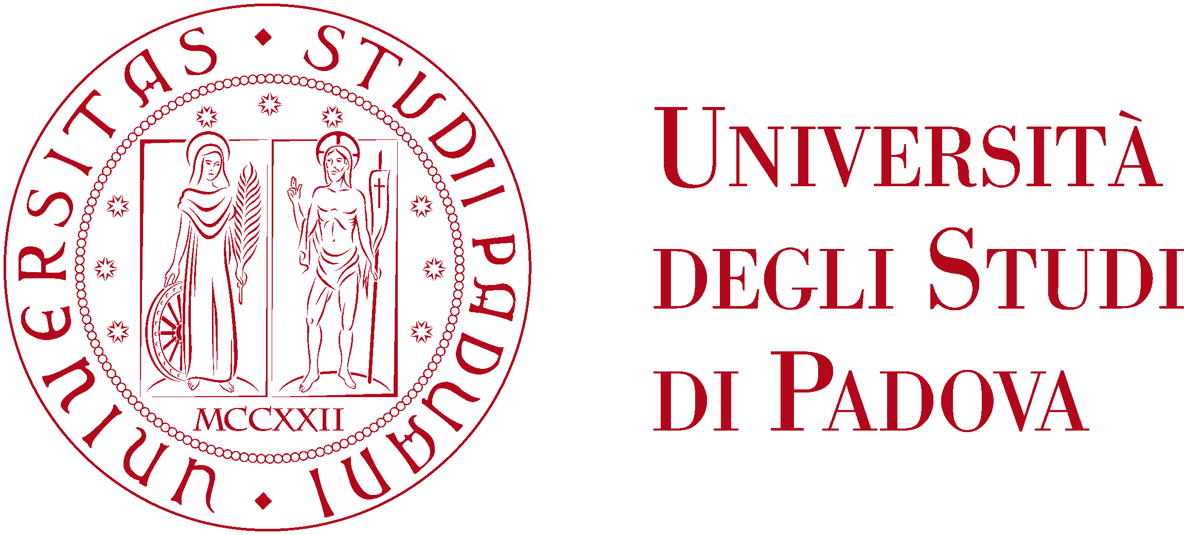

Master’s Degree in Computer Science
Academic year 2023/2024

START-UP IN ICT

Prof. Fabio D’Alessi

Written by Michael Amista’

Contents

1 Introduction 3
2 Entrepreneurs 5
3. J-Curve, TRL, Start-ups 7
4 Problems and Solutions 11
5 Problem/Solution Fit 15
6 Product/Market Fit 17

1 Introduction

Course Overview:
- Introduction to Entrepreneurship / Start-Ups
- Innovation Vectors
- Running a Start-Up
- Building your Start-up

Every university has 3 fundamental missions:
- Scientific research
- High education / Teaching
- Bring everything to the public = Progress (To share culture, knowledge and to transfer the results of the research outside of the university, contributing to the overall social growth and territorial culture path.)

The third mission is the most important one but how can we bring progress? What about a start-up?

The Research/Innovation Loop
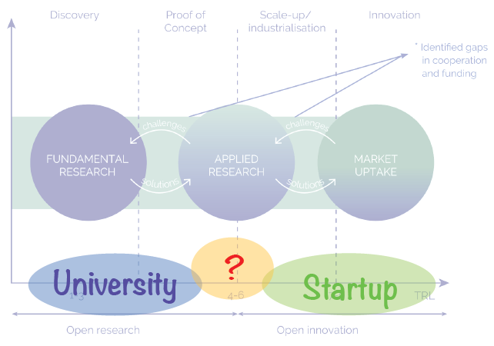

- FUNDAMENTAL RESEARCH: our stage university stage where we write papers, making projects, discover new things.
- APPLIED RESEARCH: some students want to apply what they have discovered in the previous stage, making it work!
- MARKET UPTAKE: bring the applied research to the market.

Between the open research stage and the open innovation stage there is the connection among universities and start-ups.

It is important to understand that only the university phase is not enough: university invest on us to shape a new figure in the computer science environment, then we must create innovation. Think about this: "I have a master’s degree in cybersecurity, how many banks have I protected?"

INSTANCE OF A REAL PROBLEM
Most of the shops (not e-commerce) are closing. This is related to the behaviour of people who love buy things in less time and easy way; they do not want to take the car and spend half a day to look for something to buy.
PROBLEM: how can I save shops dealing with this consumers' behaviour?
SOLUTION: if it would be possible to buy things from all the other shops with the same amazon modalities, people will buy from these shops! (START-UP)

Even Amazon was a start-up at the beginning: when people go to the supermarket, they can put things in the basket but then, before buy those items, buyers can also remove them if they are not convinced we have all the time to do that before reaching the payment phase. Amazon understood that and it provides a way to buy things in just two clicks and then it is too late to remove items from basket because we have already bought them! We are monkeys that wish to want different goods and Amazon understood that.

2 Entrepreneurs

Who is an “Entrepreneur”? Some definitions:
- “Entrepreneurs are individuals who exploit market opportunity through technical and/or organizational innovation” [Schumpeter, 1965]
- “Entrepreneurship is about taking risk” [Peter Drucker, 1970]
- “An entrepreneur is a person who habitually creates and innovates to build something of recognized value around perceived opportunities” [Bolton and Thompson, 2000]
- “An entrepreneur is a person who sets up a business or businesses, taking on financial risks in the hope of profit.” [Dictionary]
- “Entrepreneurship is the creation or extraction of value. entrepreneurship is viewed as change, generally entailing risk beyond what is normally encountered in starting a business, which may include other values than simply economic ones.” [Wikipedia]

NOTE: when we talk about “value” we do not refer to “money” which are just a consequence, but we are referring to “social, human and cultural value”. Money are just a unit of measure about how well we are doing but are not the purpose of a start-up.

All the previous definitions try to answer to the main question but none of them gives the final answer. They give clues but no one is completed.

DEFINITION USED IN THE COURSE: “Entrepreneur is “a Hero”… one that accepts risks to pursue a bigger value, often “destroying” what is known.” [Fabio D’Alessi]
Entrepreneurs takes risks to find a way to bring progress and value in society money are just a consequence, a tool to reach goals, a measure to judge how much well we've done. Entrepreneurs brings progress risking to lose everything, it is for this he's a hero.

The Hero’s Journey

Whoever you believe (Jesus, etc.), the story always follows the same path. These stories are always shaped around an important person who is leaving his life normally and then he thinks that there is more outside. It is not so simple to get up from the sofa (comfort zone) and explore what there is beyond because we are programmed in this way: we do not prefer to take risks!
Threshold is the zone where the "known" meets the unknown". Transformation is the point where the hero understands how to solve the upcoming trouble. Then the hero returns to his life bringing progress into society.

Why people write their stories always in the same way?
- A person on the sofa thinks to do something different (idea).
- When the person decides to do what he thinks, and he plans it (movement).
- The person does that (encounter).
- The person checks the act (revision). Without revision phase an individual does not learn from his mistakes.
The whole procedure is a cycle, if one of these parts is missing there is a bug in our brain. This is what we need to do with our start-up.

3. J-Curve, TRL, Start-ups

J-CURVE
In the context of startups, the J-curve refers to the trajectory of a startup's performance over time, particularly in terms of its financial metrics or user growth.
Initially, after a startup is founded, there may be a period of investment and development where the company's expenses exceed its revenues, resulting in a decline or negative trend in financial metrics. This phase is often referred to as the "Valley of Death".
However, as the startup continues to iterate on its product, refine its market strategy, and gain traction with customers, there is typically a point where it begins to experience rapid growth and a positive inflection point in its performance. This upward trajectory resembles the rising portion of the J-curve.

Standard J-Curve
e3
e2
e1
e0

Common start-ups’ behaviour:
- At the beginning we have 0 euro. We don't have a place where we can work. We don't have the technology.
- Therefore, we start to spend money to get the missing tools, having so a decreasing line (starting from e0).
- After a certain point something happens:
  - e0) incorporation;
  - e1) first customers, someone believe in us, here we are still losing money but less;
  - e2) starts to have profit, the most important point, the company turns positive;
  - e3) breakeven point, we are successful entrepreneurs, we are someone. From this point all the things go well. We do not have losses to care about, we have reached the initial point status where loss = profit.

Most dangerous zone: “Valley of Death”. Many start-ups fail here because the previous graph refers to a good j-curve (a standard one) but the parameters such as wages, entries and so on are not equal for all start-ups. If we zoom the curve behaviour, we will see that the curve is not so linear as it seems, but the behaviour can be slightly different (e.g. continuously up, down, up, down). There is no manual that tells us how to proceed!

NOTE: Larger investors give you more money starting from the e3 stage because this is a safer zone compared to the previous ones during the path, so their returns here are less: the risk gives you money!

TECHNOLOGY READINESS LEVEL (TRL)
The Technology Readiness Level (TRL) is a metric used to assess the maturity of a particular technology. It originated from NASA and has been widely adopted in various industries, including aerospace, defense, energy, and technology development.

The TRL scale typically ranges from 1 to 9, with each level representing a specific stage of technology maturity:
- Basic principles observed: This is the lowest level, where scientific research begins to be translated into applied research and development. [idea at bar]
- Technology concept formulated: In this stage, the concept is formulated, and early experiments or studies validate the basic viability of the technology.
- Experimental Proof of Concept: Key components or critical functions are demonstrated through analytical studies or basic experiments.
- Technology validated in lab: At this level, individual components or subsystems are tested in a laboratory environment to validate their functionality.
- Technology validated in relevant environment: The technology is tested in a simulated or relevant environment to demonstrate its functionality outside the laboratory.
- Technology demonstrated in relevant environment: A prototype or model of the complete system or a significant subsystem is tested in a relevant environment to validate its performance.
- System Prototype Demonstration in operational environment: A prototype of the complete system is tested in a space environment or under conditions closely resembling the intended operational environment.
- System complete and qualified: The technology is fully developed, tested, and qualified for its intended purpose. It is ready for operational deployment.
- Actual system proven in operational environment: The technology has been proven in successful mission operations or real-world applications.

NOTE: deployment phase (TRL7, TRL8, TRL9) is crucial because the product is tested from others who do not know how to use the product.

The TRL provides a standardized framework for assessing the readiness of technologies, helping stakeholders, investors, and policymakers understand the progress of technology development and make informed decisions about funding, deployment, or further research and development.

START-UPS
Def. A startup is a temporary organization used to search for a repeatable and scalable Business Model.

Comments:
- “Temporary” because there is not written anywhere that a company has to survive forever.
- In the first moments a startup does not produce goods, it searches for how to reach/do its purposes.
- Typical phases of a start-up: search; validating; scaling up.
- Startup is an organization that walks through the valley of death, looking for a way to reach its purposes (search) and eventually scaling up.
- Artisan (can build maybe 1 tesla) vs Elon Musk (thousands of teslas = industrialized model)
The goal is scaling up QUICKLY after the valley of death. It is possible to scale up quickly, for instance, choosing matured technologies to develop the novel good (amazon databases vs our little database) in this way we are immediately ready after the valley of death.
Start-ups can be distinguished between six different types:
- Lifestyle Business: A business run by its founders primarily with the aim of sustaining a particular level of income and no more; or to provide a foundation from which to enjoy a particular lifestyle. A lifestyle business’s goal is to provide a great quality of life to its owners.
- Small Businesses: They work as hard as any other entrepreneur. They hire local employees or family. Most are barely profitable. Small business entrepreneurship is not designed for scale, the owners want to own their own business and “feed the family”.
Example: home based food services; plumbing; restaurant; small niche markets.
- Startups designed to be scalable: Scalable startups tend to group together in innovation clusters (Silicon Valley, Shanghai, New York, Boston, Israel, etc.). They make up a small percentage of the six types of startups, but because of the outsize returns, attract all the risk capital (and press). Example: Airbnb, Uber, Netflix, …
- Startups designed to be quickly sold: Their goal is not to build a billion-dollar business, but to be sold to a larger company. Example: pharma, hitech. The goal of the management is different than that of building a profitable business.
Example: It is possible to discover something new which is not repeatable as business model, for instance the COVID vaccine: the goal is to discover it before the other and then sell it immediately and to sell it immediately you should go to a big company that can produce the goods for the market (in this example “COVID vaccine”, you cannot produce it yourself).
- Startup from Large Companies: Changes in customer tastes, new technologies, legislation, new competitors, etc., can create pressure for more disruptive innovation, requiring large companies to create entirely new products sold to new customers in new markets. They are “transformational innovation projects” of large companies.
It may start from an employee's idea who can propose the novel idea to his boss. If the boss is convinced, he can accept the new ideas' business model.
Main reasons to do this type of business:
  - failure (10%);
  - branding loyalty (20%): we can exploit the main brand if the idea is successful;
  - flexibility;
  - speed (50%): in a big company is harder to plan the activity of a new project, months to build and project the team's activity;
  - motivation: the ambition to do/earn more, the ambition to succeed.
- Social start-ups: Usually they are charitable initiatives, their goal is to make the world a better place, not to take market share or to create to wealth for the founders. Typically, they receive money from donation, sponsorships but their goals are not to earn revenues but to bring social welfare.

In the call to adventure phase, we should decide: What kind of startup are we going to launch/ What is our purpose/ What do we want to become?

4 Problems and Solutions

PURPOSE AND IMPACT
What change do you want to bring about in the world and what is the reason your organization exists. Your purpose is the fundamental message that fires your people up, brings them to work for more than just a paycheck, and gives meaning to their efforts.
It is often the very idea that launches a company in the first place, sustaining and guiding it through the earliest stages. The idea is the key point: we have all the tools and technology (AI, databases, programming languages) to reach our goal, the novel work is finding a way to apply those tools on a really important scenario.

How are you going to make it?
What makes your approach unique and recognizable? What is your characteristic “way”, how will you bring about the change envisioned in your purpose? It’s inspired by your organization’s culture, strategy and "core values”. Your first stakeholders will be your cofounders, family and friends.

The impact statement should be more aspirational than the Purpose Statement – more of a stretch – because you may never quite get there, but it will keep people motivated and sustain the organization in its later stages of growth.

VISION, MISSION, VALUE
Vision: describes, in a simple, immediate way, the major aspirations of an organization, what is hopes to achieve or become.
Mission: describes, in a simple, specific way, how the organization is going to achieve its Vision.
Values: defines what the organization believes in and how people of the organization are going to act and behave. Code of Ethics. The whole company is structured around this.

Google:
- Vision: “Providing an important service to the world, instantly delivering relevant information on virtually any topic.”
- Mission: “Organize the World’s information and make it universally accessible and useful.”

Twitter:
- Vision: “We believe in free expression and think every voice has the power to impact the world”.
- Mission: “Reach the largest daily audience in the world by connecting everyone to their world via our information sharing and distribution platform products and be one of the top revenue generating Internet companies in the world.”

IDEAS AND INNOVATION
The idea cannot start from a solution, it starts from a problem. If the problem is interesting and involves a large amount of people, it could be a good idea for a start-up.
Ideas may come from academic projects or industry experience or any other experience which may spark intuition of a need. Ideas are often associated to assumptions and assumptions are what make great ideas fragile or vulnerable.
Remember: ideas, alone are “worth nothing”.

Innovation = invention * commercialization (Bil Aulet, MIT).
The innovation cannot happen without taking the innovative good to the market and commercialize it. Commercialization is often forgotten, and it is just as hard: it is a research objective, it requires experimentation and, if totally neglected, brings the whole Innovation equation to zero (“worth nothing”). Be sure that there’ is a market that wants your product before you build it.

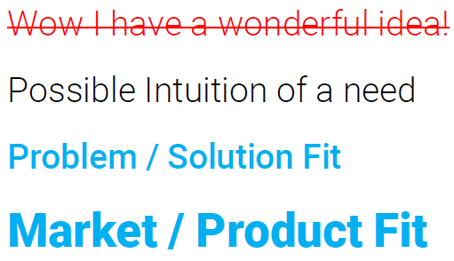
Real start-up steps:

Who can buy this product? Everybody is always a wrong answer: when we hear "everybody" the idea is never good. We need to know people and their problem to shape an innovative product, from the intuition on a need!
Problem/Solution Fit: validate the problem and find a solution.
Market/Product Fit: find a way to sell the solution (selling the product for too much money it is not always a good idea because it reduces the potential buyers).

Maslow’s hierarchy of Needs
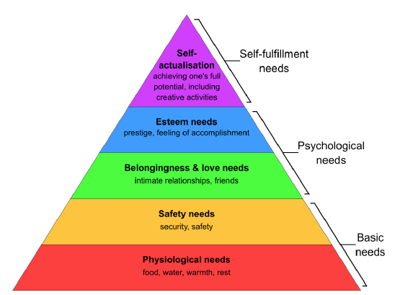
More the problem is down in the pyramid more valuable the innovation is.
We don't care about the needs of one level before fulfilling the needs from the previous levels.
The physiological needs are much important because if we are dying, we don't care about the other problems, we need to solve this before thinking others!
Facebook was innovative because its purposes were psychological needs.

DEFINING YOUR PRODUCT
How to validate a “correct” problem?
- Bottom-up street Data based. “Get out of the Building”:
  - Ask Who will buy it
  - Get to the Inner Need: The Pain
  - How the Solution will change user’s lifeRoutine. Describe pre/post User Journey
- Why now? Can you do it, now?
- Why you? IP meaningfulness
- Then iterate the whole procedure.

Who is working on a start-up, so on a problem, between those two photos?


The second one is a real start-up meeting, they are studying the market directly on that environment. The first photo simply represents a developing phase, it is the easiest phase that cannot bring innovation.
Study the market before developing a new product (e.g. if a I have a good idea of an innovative compact disk, but no one use a compact disk we have fail from the beginning!). Elon Musk studied the market for a lot before building tesla's car.

The product is always the final destination. It is simple to write a general app in Flutter but if I have to think about the app that can dominate the market none has an idea. A product is just something that makes me happy.

CREATING YOUR PRODUCT
Creating a product it’s all about market and people, not about products and technology. We have two options:
- The Product Development Model: The Path to Disaster. Where is the Customer??
It allows to develop applications and products in an effective way. In this model there are several documents which talks about product features (big/small button why red/white?) but none of these documents talks about customers. The product developed with this model is technically perfect, but it does not consider customers.
- The Customer Development Model: The Path to Epiphany. The real question: why customers do what they do?

Value proposition: the Key mindset in defining your Value Proposition is focusing on a real problem to be solved rather than on a technical solution which is really cool.
Value is the first thing to define about your start-up (e.g. Google: "to provide users with the most relevant and useful search results possible, quickly and efficiently").
Example: A famous Pizza-Start-up (name?): what is the problem of pizza delivery? The pizza arrives cold effective value proposition "if the pizza is not smoking hot, you get it for free", a great example that differentiate this pizza shop from all the other hundreds. Again, think about the people problems, it is the key!

The value proposition is the problem, the solution comes after.

The Key Value Proposition is Validated following two fundamental steps:
- Problem/Solution Fit
- Product/Market Fit

5 Problem/Solution Fit

By definition is the fit of solutions which resolve problems. The phase of the start-up where we understand if the problem is the real one.
Remind the problem of amazon killing the small shops the problem is not "amazon wants to kill small shops" but that “small shops do not use computers”.

The problem is never what people say, we need to go deeper (e.g. "problem of wasting time", wasting time can happen anywhere "wasting time on a queue", there are different scenarios with a queue "I am in a queue to access to customer service office").

The white parts of the diamonds referred to the phases where we ask people about problems and solutions. The grey parts of the diamonds referred to the phases where we analyse the collected data from interviews to people; if doubts come out, it is possible to reiterate the diamond to collect other data to analyse and complete the problem definition/solution validation.

Magic tricks that can be used during or after interviews:
- 40% rule: is there a connection between people problems? If the 40% of the interviewed people say the same problem, then there is a problem to work with!
- When we find something interesting, ask “why?” because we can learn something undiscovered.
- Five Whys rule: is a problem-solving technique aimed at getting to the root cause of an issue by asking "why" iteratively. The idea is to dig beyond the surface symptoms of a problem by asking "why" repeatedly until the fundamental cause is identified. Typically, five iterations of "why" are used, although the number may vary depending on the complexity of the problem.
- SFTC (Solve it For The Customer): is a customer-centric approach or mindset commonly adopted by businesses, particularly in product development and service delivery. It emphasizes prioritizing the needs, challenges, and satisfaction of the customer above all else.
- Look for delight.
- Follow strong signals, not strong numbers.
- Never think at the product.
- The "invalidation" method: after I identified a problem, try to invalidate the problem, if the problem persists, we have a problem to deal with!
- Canvases.
- Experiments.

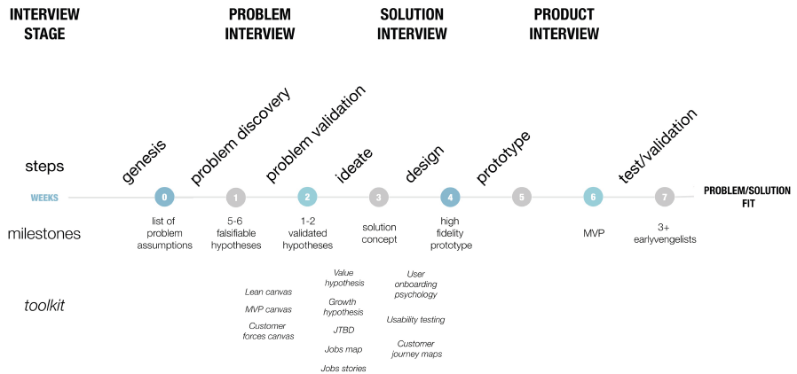

Early-Evangelist: at the beginning there are not so many people who care about an early solution and those who care are called early evangelist and they can test your product for free! Exploit this! Early evangelist are those individuals who can test the product before others and they can show it to friends, family and so on (ChatGPT used a similar approach).
They are crucial when the start-up needs to have customers, big companies do not care about them because they have billion of users but at the beginning they are crucial, write down their name. They can be:
- Early adopters, who buy unfinished and untested products because they want to be “first” to:
  - build a competitive edge;
  - be glam.
- Leaders, with technical competence on how to use new solution to existing problems they face
- Those willing to make a leap of faith and buy an early solution.
- Enthusiasts, who spread the good news about the product, for others to follow.

6 Product/Market Fit

…

